**Experiment No.5**

**Aim:**  Edit/compile/run a program to read a four digit number through the keyboard and calculate the sum of its digit.

**Program A:**

def getSum(n):  
 sum = 0  
 for digit in str(n):  
 sum += int(digit)  
 return sum  
  
n = 2408  
print(getSum(n))

**Output:**

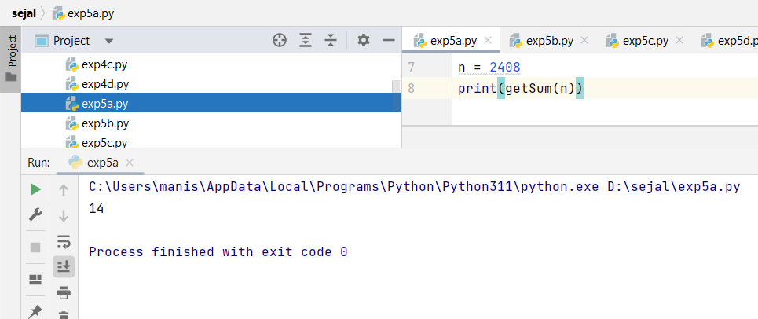

**Program B:**

def getSum(n):  
 sum = 0  
 while (n != 0):  
 sum = sum + (n % 10)  
 n = n//10  
 return sum  
n = 2542  
print(getSum(n))

**Output:**

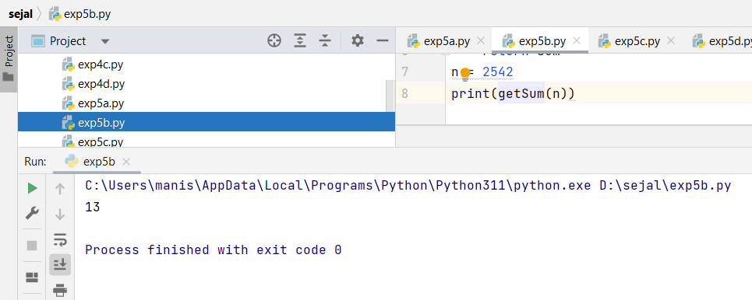

**Program C:**

def sumDigits(no):  
 return 0 if no == 0 else int(no % 10) + sumDigits(int(no / 10))  
  
n = 7534  
print(sumDigits(n))

**Output:**

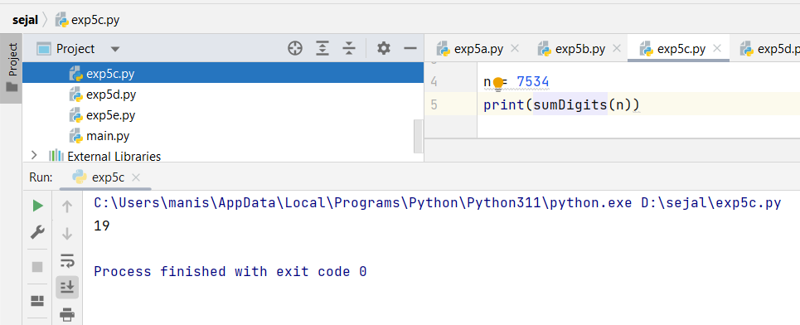

**Program D:**

def getSum(n):  
 strr = str(n)  
 list_of_number = list(map(int, strr.strip()))  
 return sum(list_of_number)  
  
n = 1598  
print(getSum(n))

**Output:**

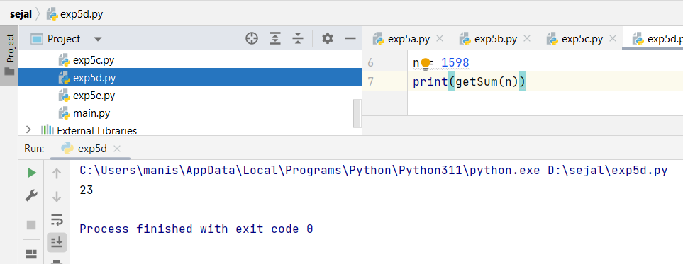

**Program E:**

number = input("Enter a four-digit number: ")  
  
if len(number) != 4 or not number.isdigit():  
 print("Invalid input. Please enter a four-digit number.")  
else:  
 sum_of_digits = 0  
 for digit in number:  
 sum_of_digits += int(digit)  
  
 print("The sum of digits in", number, "is", sum_of_digits)

**Output:** If 4 digits are entered correctly:

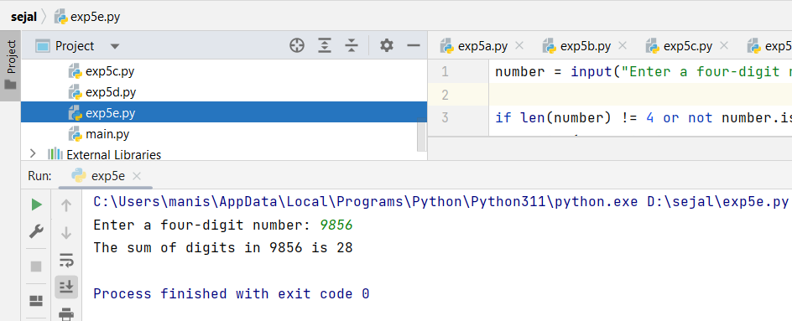

**Output:** If 4 digits are not entered:

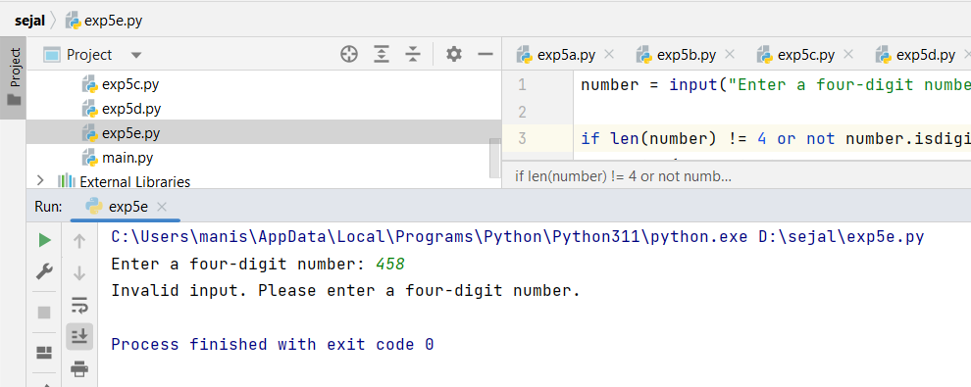

|  |  |  |  |
| --- | --- | --- | --- |
| **Practical Performance**  **(4)** | **Writeup & Oral**  **(4)** | **Attendance**  **(2)** | **Total**  **(10)** |
|  |  |  |  |